78.01.30c
To the Surveyor General of South Australia
E1652/1/1878/2801, National Archives of Australia, Darwin.

NORTHERN TERRITORY

APPLICATION FOR LEASE OF PASTORAL LANDS, UNDER ACT 48, 1876.

Term twenty five Years from 1st April 1878
Application No. 2801 of
containing 50 square miles £1 :5/ - Dated 30 January 1878

I Ferdinand Jacob Heinrich von Mueller of Melbourne Victoria do hereby make application for a Lease of a certain portion of the Waste Lands of the Crown in the Northern Territory of South Australia, the situation and boundaries whereof are shown in the Plan hereto annexed, to which I have affixed my signature; and I make the above claim under clause 4 of the Regulations now in force (dated 28th December, 1876).
F. J. H. von Mueller
by his agent F Krichauff
Witness—
James Binnie
___________
Telegram under clause 5, sent to Northern Territory, dated 30th January 1878
Approved by Government Resident, vide Telegram dated 1878.
___________
Forwarded to Treasury for receipt of first year's Rent, viz.:— £ 1 : 5/ : –
[illegible initials] pr Surveyor-General.
25/4 1878
___________
Received the above amount of £ 1 : 5/:– this 25th day of Apl 1878.
C.R.T.
pro Treasurer.
______________
being the holder of a preferential right to a lease of Run No. , do solemnly declare that the said Run has been stocked, and continues to be stocked to the extent required by clause 2 of the Regulations under "The Northern Territory Land Act, 1876."
(Signature) __________________

Declared before me at this day of , 18 .
(Signature) _______________ J.P.

Near the Mouth of the Roper
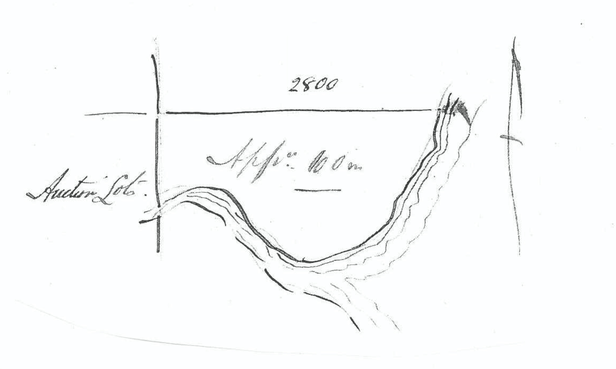
SCALE:— Four miles to one inch

I accept the above diagram as my act and deed.
F. J. H. von Mueller
by his agent F Krichauff

Annotated: 'Copy for Adelaide'.
Space left blank.
See notes to M to the Surveyor General of South Australia, 30 January 1878.
Image courtesy of the National Archives of Australia. 78-01-30c_image01.jpg In the original sketch the line above which ‘2800’ is written, from the western boundary to the coast, is approximately 6.7 cm long. The number ‘2800’ corresponds to the land applied for in M to the Surveyor General of South Australia, 30 January 1878 (in this edition as 78-01-30b), but it is difficult to reconcile this with the sketches given there and in the other two applications lodged on M’s behalf on the same day (in this edition as 78-01-30 and 78-01-30a).

